**MEGA BRACKET WALL MOUNTED FANS:**

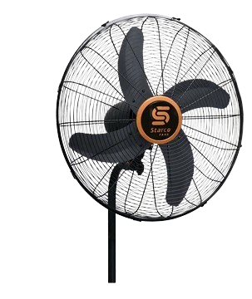

**Price: 12,195.00**

The Mega Bracket Fan is a high-performance ventilation solution, designed to provide powerful airflow and intense cooling relief in a sturdy and adjustable design. With its robust motor and large blades, this fan delivers a strong and focused breeze, effectively cooling large areas and improving air circulation. Its adjustable bracket design allows for flexible mounting options, making it an ideal choice for homes, offices, warehouses, and other spaces where a reliable and heavy-duty cooling solution is required.

**Key features of mega bracket wall mounted fans include:**

* **Heavy-duty bracket design** for secure and stable mounting.
* **Multiple speed settings** (usually 3) for adjustable airflow.
* **Oscillation function** for wide air distribution.
* **Adjustable tilt** for directing airflow precisely.
* **Robust motor** for high performance and durability.
* **Quiet operation** for minimal noise during use.
* **Space-saving wall-mounted installation** for efficient use of space.
* **Safety features** like protective grills for user safety.